Week 3 assignment

Adding connect JIRA button in front end

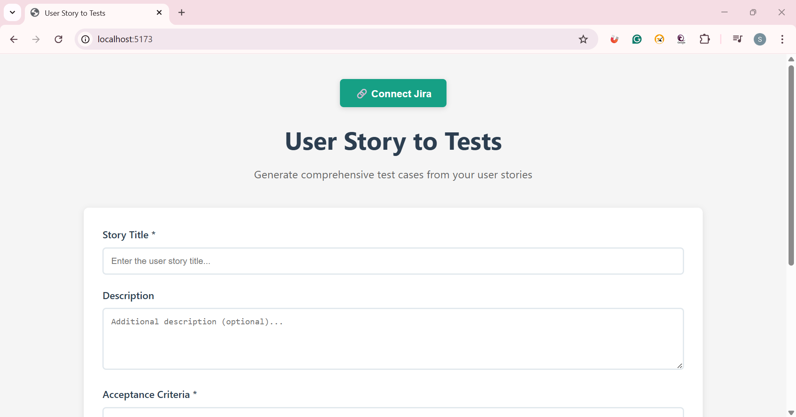

Ask LLM to move either of the top corner (vibe code)

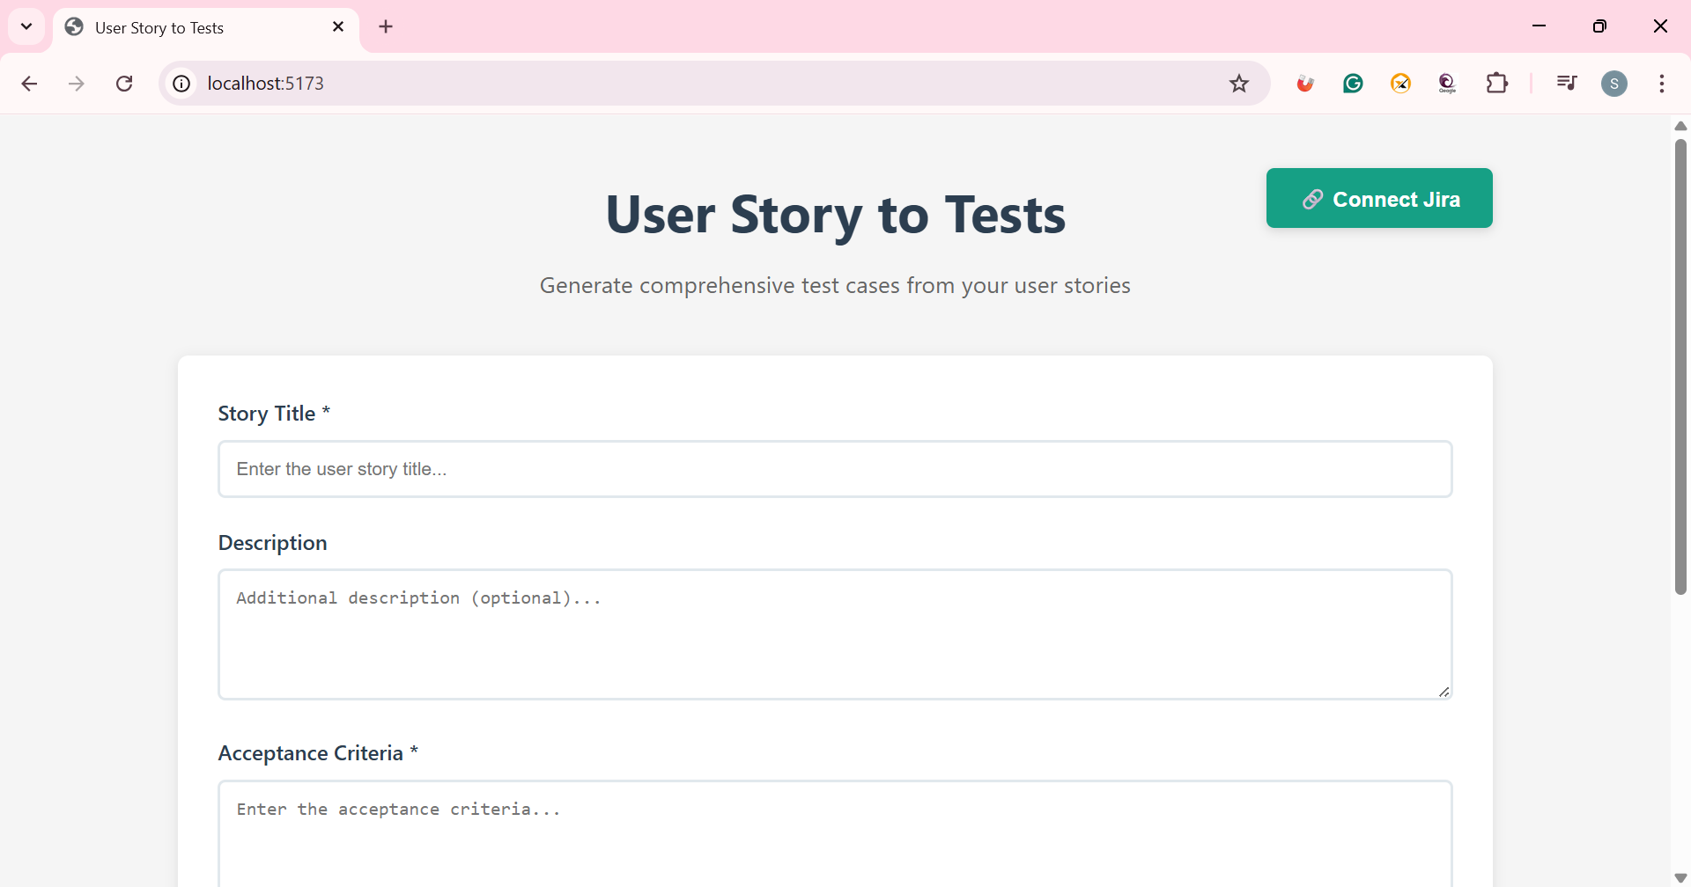

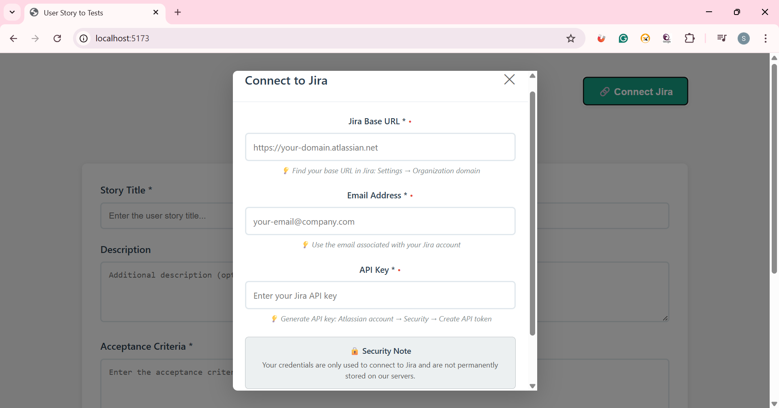

Week 3 assignment on back end connectivity to JIRA board and import User story then proceed on test case generation

Click on Connect Jira, enter credentials
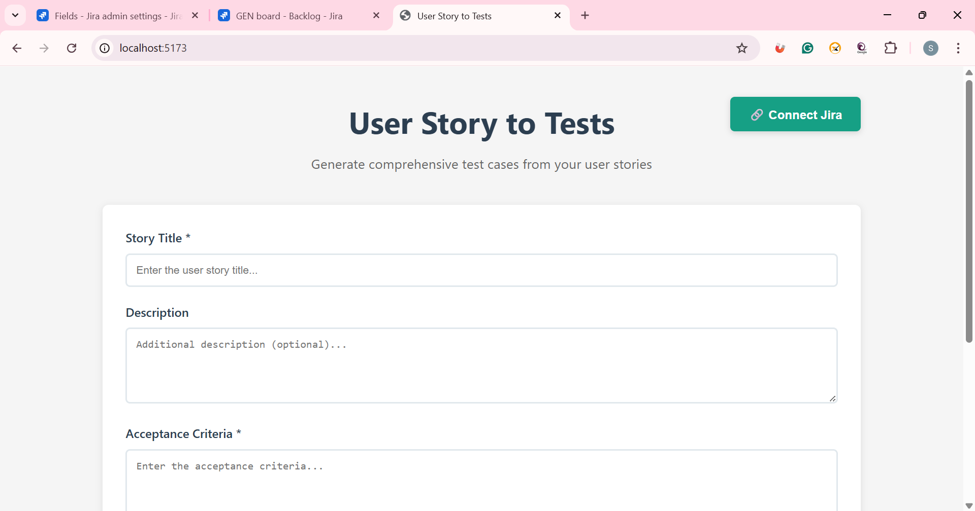

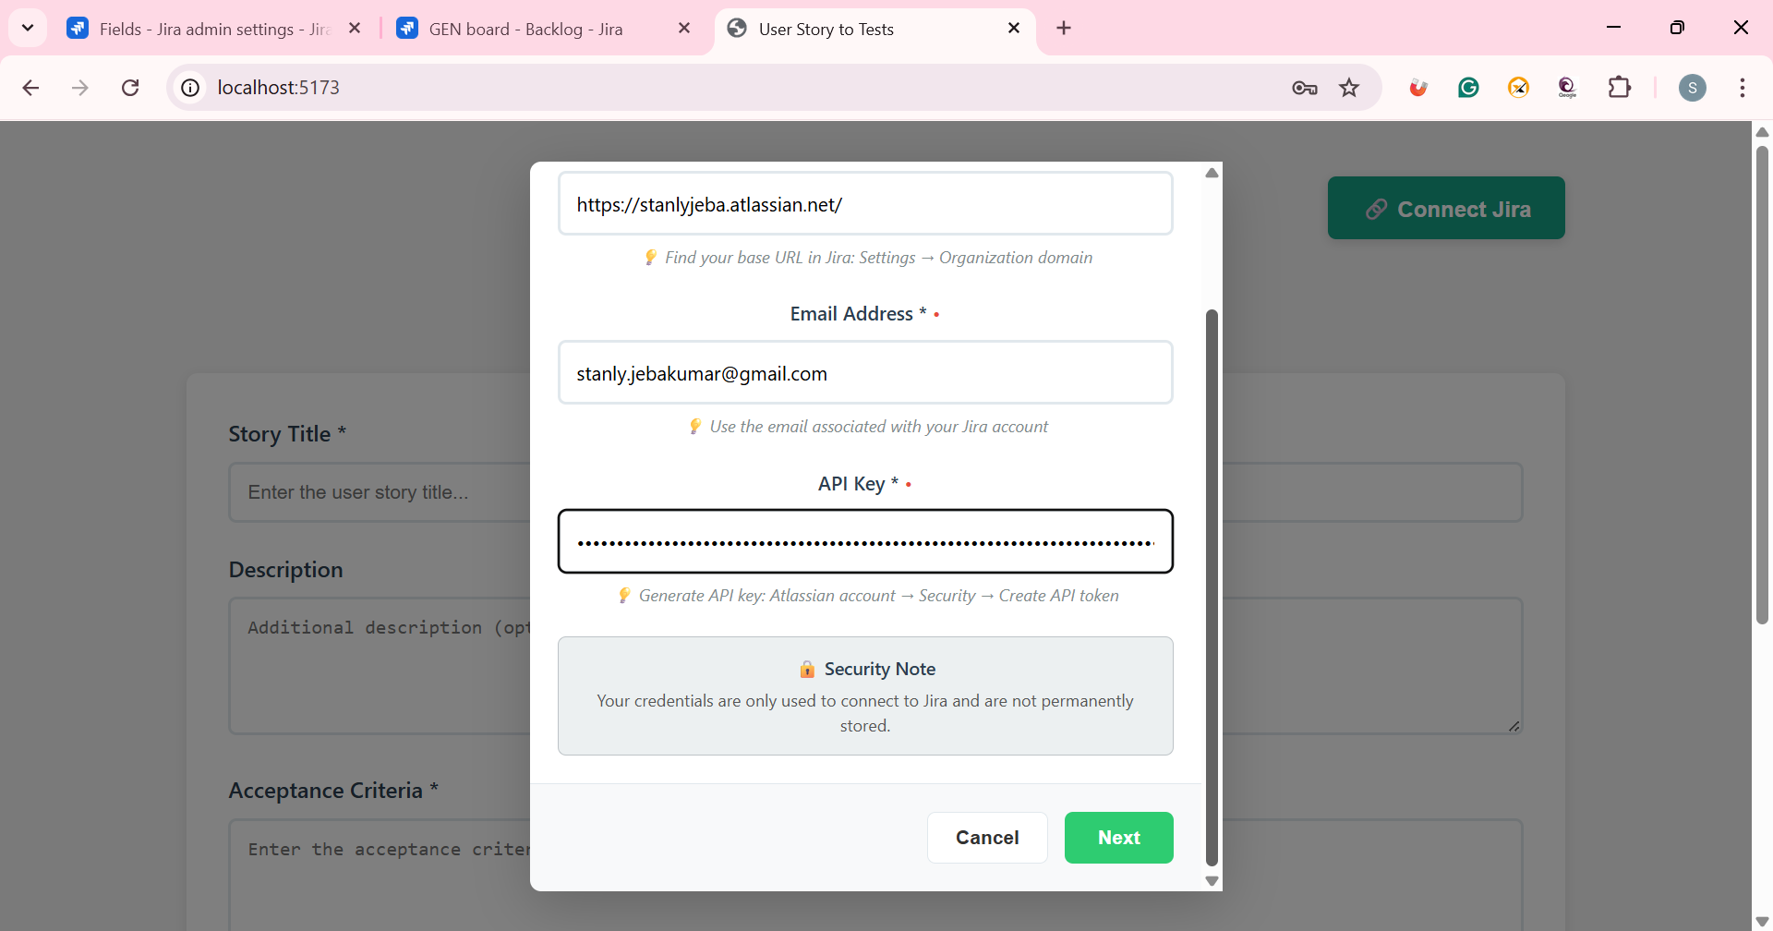

Click on Next
There is a prompt – user to enter needed stories to be imported
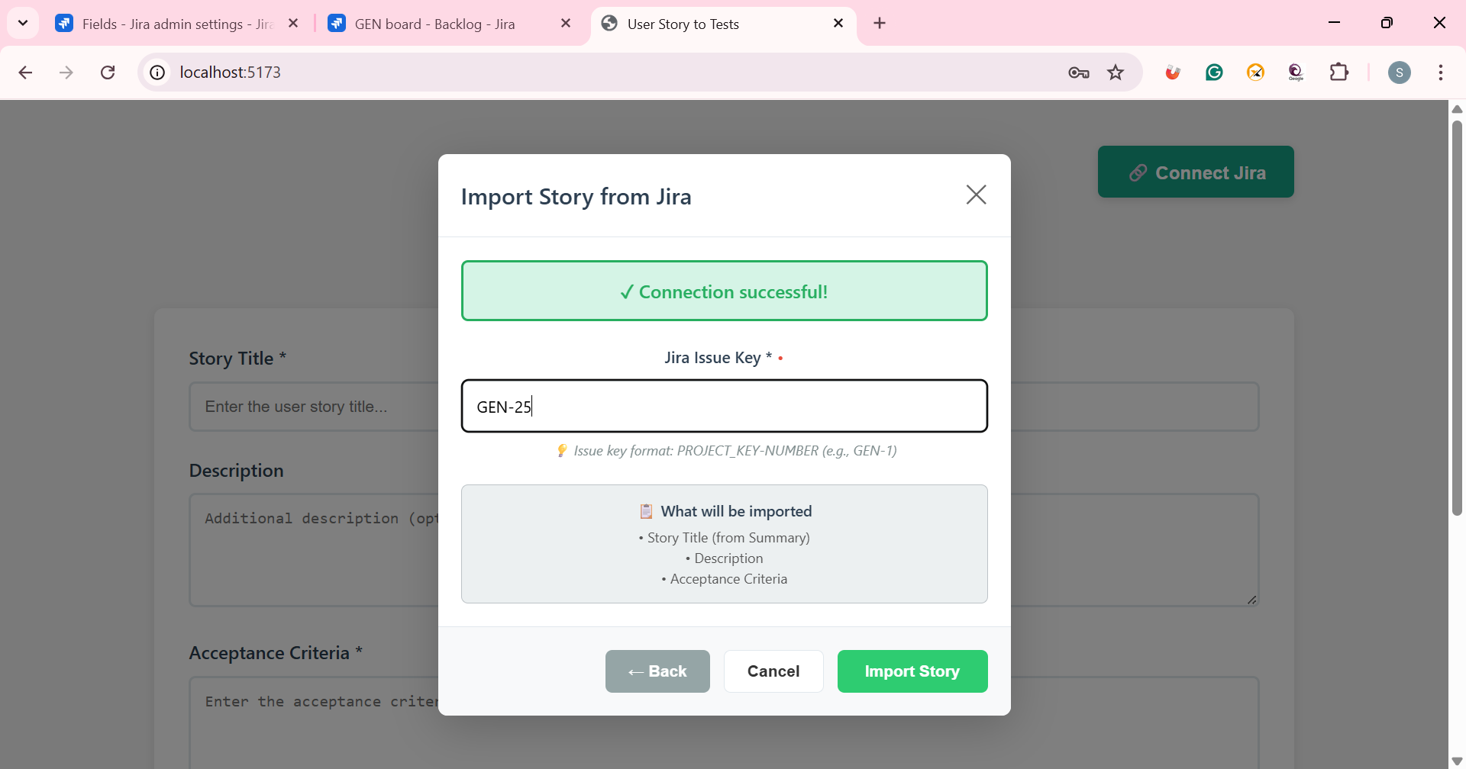

Click on Import Story

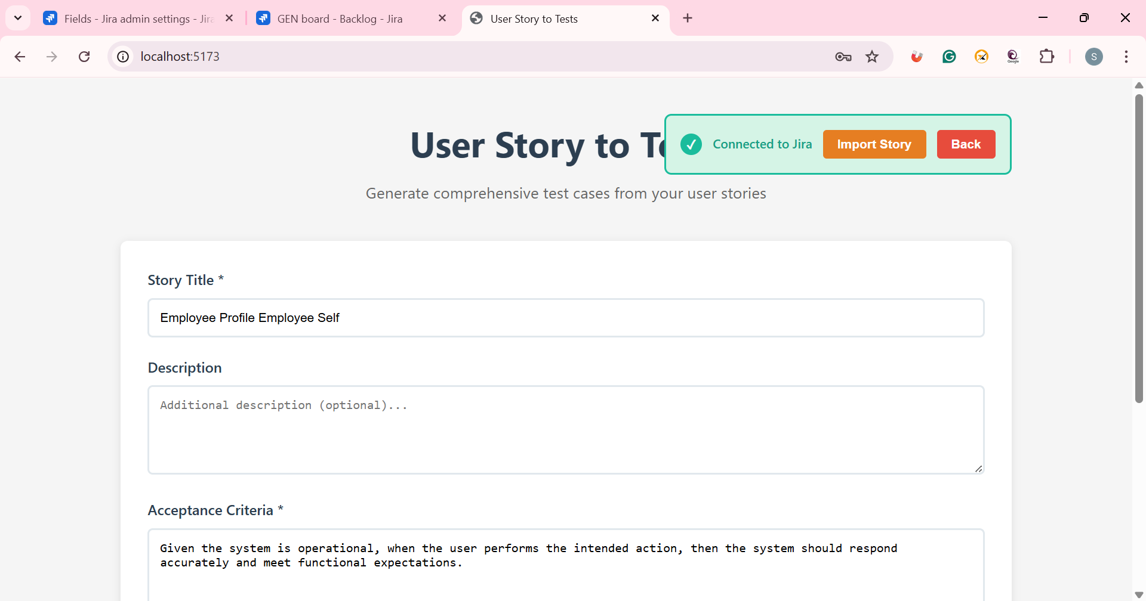

Click on Generate - to generate test cases
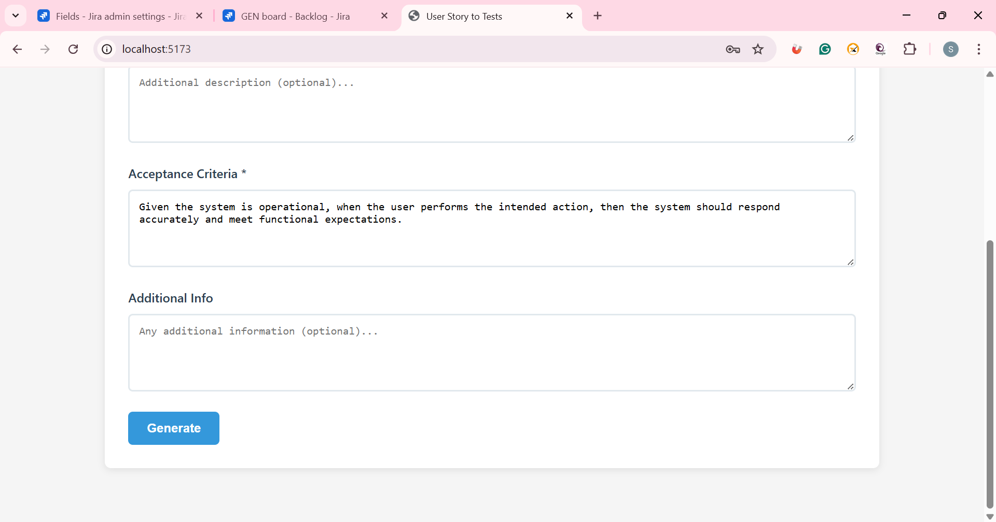

Test case generation successful
